CMV Warning Device Placement Aid

Visual Example: Straight, Two-Lane Road

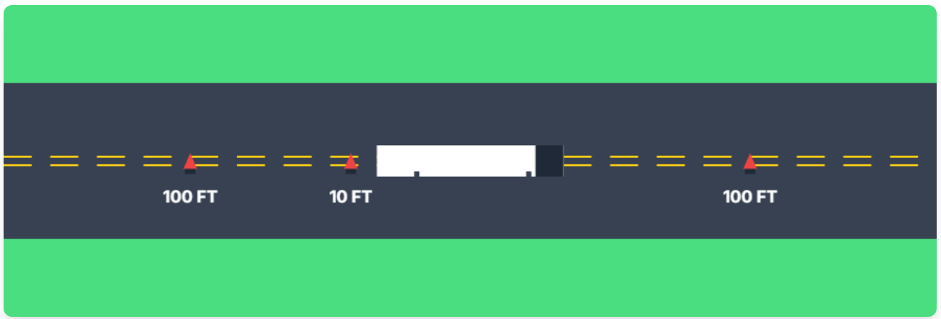

Emergency Warning Triangle Placement Rules

General Steps for Placement
- Safety First: Pull over as far out of traffic as possible and turn on your hazard lights.
- Wait for Traffic: Wait for a safe break in traffic before placing the triangles.
- Place Triangles: Follow the placement guidelines below based on the road type.

Road Type-Specific Placement Summary
On a Straight, Two-Lane Road
- Rear Triangle 1:10 feet behind the vehicle's rear on the traffic side.
- Rear Triangle 2:100 feet behind the vehicle.
- Front Triangle: 100 feet in front of the vehicle.
On a Divided Highway or One-Way Road
- Rear Triangle 1: 10 feet behind the vehicle.
- Rear Triangle 2: 100 feet behind the vehicle.
- Rear Triangle 3: 200 feet behind the vehicle.
- *(Note: A front triangle may not be needed or required on divided highways but check local regulations).*
On a Curve, Hill, or Obstructed View
- Rear Triangle 1:10 feet behind the vehicle.
- Rear Triangle 2: 100 to 500 feet behind the vehicle, adjusted so the triangle is visible from at least 500 feet away.
- Front Triangle: 100 feet in front of the vehicle.

Key Considerations
- Timeframe: Place triangles within 10 minutes of stopping.
- Visibility: Ensure triangles are placed in the center of the lane or shoulder for maximum visibility but positioned so they don't guide drivers into your truck.
- Visibility Aids: Consider using LED road flares in addition to triangles for enhanced visibility.

